Project Design Phase
Weather Solution Architecture

Date | 30 September 2026
Team ID | SWTID-2026-1362
Project Name | Weather Wise
Maximum Marks | 4 Marks

Solution Architecture:
Solution architecture is a complex process – with many sub-processes – that bridges the gap between business problems and technology solutions. Its goals are to:
- Find the best tech solution to deliver accurate, real-time weather information and forecasts to users.
- Describe the structure, characteristics, behavior, and other aspects of the software to project stakeholders.
- Define weather features (current conditions, forecasts, alerts), development phases, and solution requirements.
- Provide specifications according to which the solution is defined, managed, and delivered.

Example - Solution Architecture Diagram:

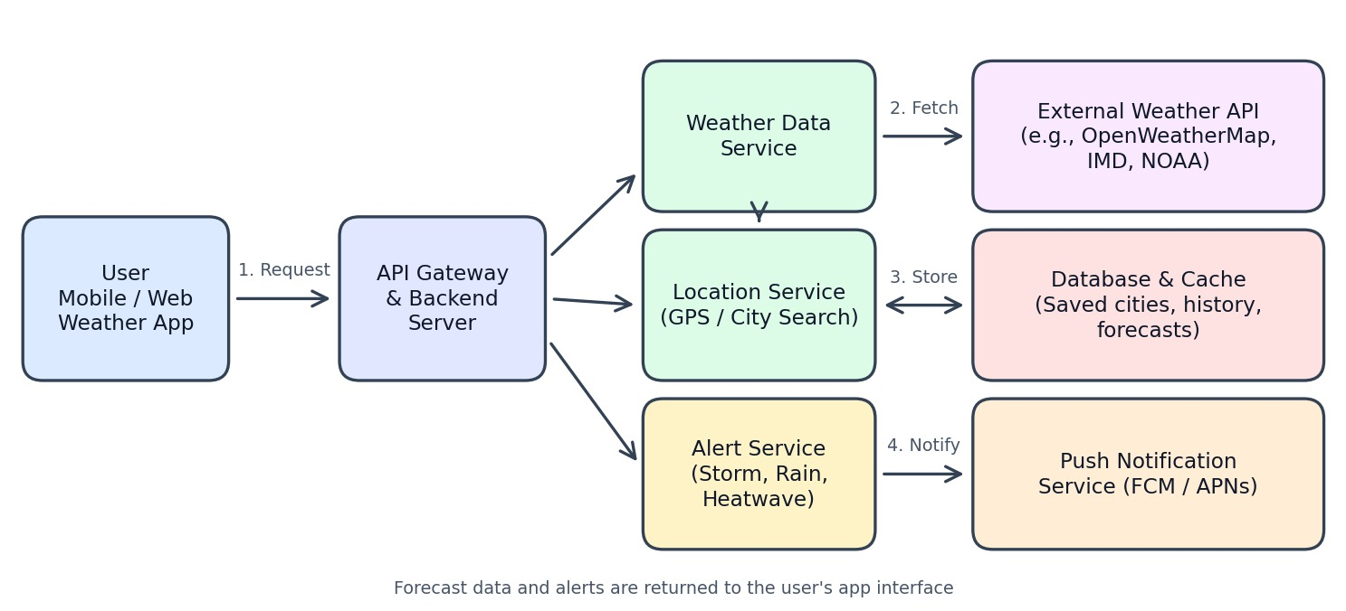
Figure 1: Architecture and data flow of the weather forecasting application
Reference: https://openweathermap.org/api

